Choose color
http://www.2createawebsite.com/build/hex-colors.html

Click in one color and it will provide several combinations
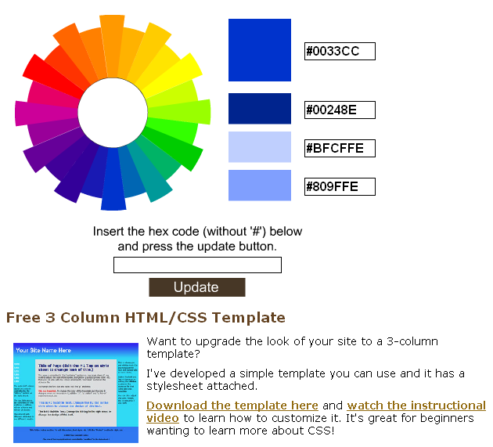

#0033CC
#00248E

Create frame

http://www.roundedcornr.com/

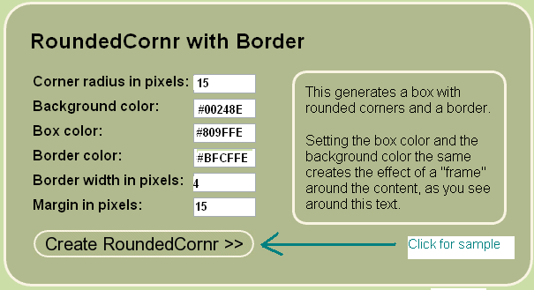

- Background should be darker
- Border color should be lighter
- Box color should be between darker and lighter
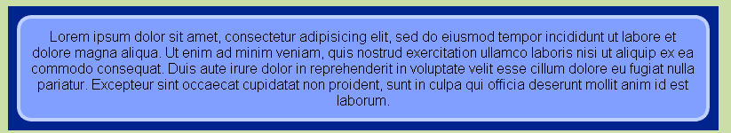

This is how it looks like

The HTML should be

<div class="roundedcornr_box_754638">
<div class="roundedcornr_top_754638"><div></div></div>
<div class="roundedcornr_content_754638">

<p>Lorem ipsum dolor sit amet, consectetur
adipisicing elit, sed do eiusmod tempor incididunt
ut labore et dolore magna aliqua. Ut enim ad minim
veniam, quis nostrud exercitation ullamco laboris
nisi ut aliquip ex ea commodo consequat. Duis aute
irure dolor in reprehenderit in voluptate velit esse
cillum dolore eu fugiat nulla pariatur. Excepteur
sint occaecat cupidatat non proident, sunt in culpa
qui officia deserunt mollit anim id est laborum.</p>

</div>
<div class="roundedcornr_bottom_754638"><div></div></div>
</div>

Include this CSS Code

.roundedcornr_box_754638 {
background: url(roundedcornr_754638_tl.png) no-repeat top left;
}
.roundedcornr_top_754638 {
background: url(roundedcornr_754638_tr.png) no-repeat top right;
}
.roundedcornr_bottom_754638 {
background: url(roundedcornr_754638_bl.png) no-repeat bottom left;
}
.roundedcornr_bottom_754638 div {
background: url(roundedcornr_754638_br.png) no-repeat bottom right;
}
.roundedcornr_content_754638 {
background: url(roundedcornr_754638_r.png) top right repeat-y;
}

.roundedcornr_top_754638 div,.roundedcornr_top_754638,
.roundedcornr_bottom_754638 div, .roundedcornr_bottom_754638 {
width: 100%;
height: 15px;
font-size: 1px;
}
.roundedcornr_content_754638, .roundedcornr_bottom_754638 {
margin-top: -19px;
}
.roundedcornr_content_754638 { padding: 0 15px; }

Download from the page the following files
- roundedcornr_754638_tl.png
- roundedcornr_754638_tr.png
- roundedcornr_754638_bl.png
- roundedcornr_754638_br.png
- roundedcornr_754638_r.png

Corner radius in pixels: 30
Background color: #559fb8
Box color at top: #BFCFFE
Box color at bottom: #809FFE
Gradient height in pixels: 100

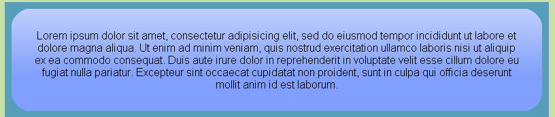

Si cambia el angulo de gradiente a 30 aparece
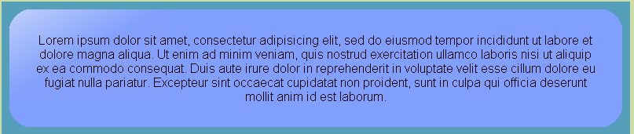

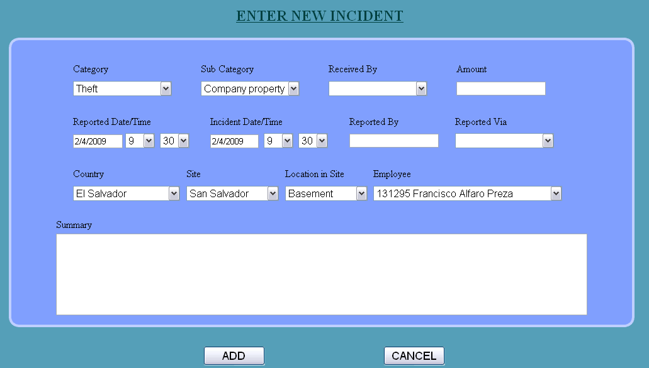

<%@ Page Language="C#" AutoEventWireup="true" CodeFile="NewIncident.aspx.cs" Inherits="NewIncident" %>

<!DOCTYPE html PUBLIC "-//W3C//DTD XHTML 1.0 Transitional//EN" "http://www.w3.org/TR/xhtml1/DTD/xhtml1-transitional.dtd">

<html xmlns="http://www.w3.org/1999/xhtml" >
<head runat="server">
<title>Untitled Page</title>

CSS CODE

<style type="text/css">

.roundedcornr_box_638600 {
background: url(roundedcornr_638600_tl.png) no-repeat top left;
}
.roundedcornr_top_638600 {
background: url(roundedcornr_638600_tr.png) no-repeat top right;
}
.roundedcornr_bottom_638600 {
background: url(roundedcornr_638600_bl.png) no-repeat bottom left;
}
.roundedcornr_bottom_638600 div {
background: url(roundedcornr_638600_br.png) no-repeat bottom right;
}
.roundedcornr_content_638600 {
background: url(roundedcornr_638600_r.png) top right repeat-y;
}

.roundedcornr_top_638600 div,.roundedcornr_top_638600,
.roundedcornr_bottom_638600 div, .roundedcornr_bottom_638600 {
width: 100%;
height: 15px;
font-size: 1px;
}
.roundedcornr_content_638600, .roundedcornr_bottom_638600 {
margin-top: -19px;
}
.roundedcornr_content_638600 { padding: 0 15px; }

</style>

END CSS CODE

</head>
<body>
<form id="form1" runat="server">
<div style="background-color: #559fb8">

<br />
&nbsp; &nbsp; &nbsp; &nbsp; &nbsp; &nbsp; &nbsp; &nbsp;
&nbsp; &nbsp; &nbsp; &nbsp; &nbsp; &nbsp; &nbsp; &nbsp; &nbsp; &nbsp;
&nbsp; &nbsp; &nbsp; &nbsp; &nbsp; &nbsp; &nbsp; &nbsp; &nbsp; &nbsp;
&nbsp; &nbsp; &nbsp; &nbsp; &nbsp; &nbsp; &nbsp; &nbsp; &nbsp; &nbsp;
&nbsp; &nbsp; &nbsp; &nbsp; &nbsp; &nbsp; &nbsp; &nbsp; &nbsp; &nbsp;
&nbsp; &nbsp;&nbsp;

<asp:Label ID="Label10" runat="server" Font-Bold="True" Font-Size="X-Large" Font-Underline="True"
ForeColor="#004040" Text="ENTER NEW INCIDENT"></asp:Label><br />

<br/>

<table width="1000" style="left:50px;position:absolute;">
<tr>
<td style="height: 311px">

<div class="roundedcornr_box_638600">
<div class="roundedcornr_top_638600"><div></div></div>
<div class="roundedcornr_content_638600">

<p> &nbsp;&nbsp;

TABLE 1

<asp:Table ID="Table1" runat="server"
Height="66px"
HorizontalAlign="Center"
Width="795px">

<asp:TableRow runat="server">
<asp:TableCell runat="server">Category</asp:TableCell>
<asp:TableCell runat="server">Sub Category</asp:TableCell>
<asp:TableCell runat="server">Received By</asp:TableCell>
<asp:TableCell runat="server">Amount</asp:TableCell>

</asp:TableRow>

<asp:TableRow runat="server">
<asp:TableCell runat="server">
<asp:DropDownList ID="Category"
runat="server"
Font-Size="Medium"
Width="157px">
</asp:DropDownList>
</asp:TableCell>

<asp:TableCell runat="server">
<asp:DropDownList ID="SubCategory"
runat="server"
Font-Size="Medium"
Width="157px">
</asp:DropDownList>
</asp:TableCell>

<asp:TableCell runat="server">
<asp:DropDownList ID="DropDownList9"
runat="server"
Font-Size="Medium"
Width="157px">
</asp:DropDownList>
</asp:TableCell>

<asp:TableCell ID="TableCell3" runat="server">
<asp:TextBox ID="TextBox1"
runat="server"
Width="136px">
</asp:TextBox>
</asp:TableCell>

</asp:TableRow>

</asp:Table>

</p>
<p>

TABLE 2

<asp:Table ID="Table2" runat="server"
HorizontalAlign="Center"
Height="64px"
Width="795px">

<asp:TableRow runat="server">
<asp:TableCell runat="server">Reported Date/Time</asp:TableCell>
<asp:TableCell runat="server">Incident Date/Time</asp:TableCell>
<asp:TableCell runat="server">Reported By</asp:TableCell>
<asp:TableCell runat="server">Reported Via</asp:TableCell>

</asp:TableRow>

<asp:TableRow runat="server">

<asp:TableCell runat="server">
<asp:TextBox ID="TextBox3"
runat="server"
Width="73px">1/1/2009
</asp:TextBox>&nbsp;

<asp:DropDownList ID="time1"
runat="server"
Font-Size="Medium"
Width="47px">
</asp:DropDownList>&nbsp;

<asp:DropDownList ID="time2"
runat="server"
Font-Size="Medium"
Width="47px">
</asp:DropDownList></asp:TableCell>

<asp:TableCell runat="server">
<asp:TextBox ID="TextBox5"
runat="server"
Width="71px">1/1/2009
</asp:TextBox>&nbsp;
<asp:DropDownList ID="time11"
runat="server"
Font-Size="Medium"
Width="47px">
</asp:DropDownList>&nbsp;

<asp:DropDownList ID="time22"
runat="server"
Font-Size="Medium"
Width="47px">
</asp:DropDownList></asp:TableCell>

<asp:TableCell runat="server">

<asp:TextBox ID="TextBox4"
runat="server"
Width="136px">
</asp:TextBox>
</asp:TableCell>

<asp:TableCell runat="server">
<asp:DropDownList ID="DropDownList8"
runat="server"
Font-Size="Medium"
Width="157px">
</asp:DropDownList>
</asp:TableCell>

</asp:TableRow>
</asp:Table>

</p>

TABLE 3

<asp:Table ID="Table3" runat="server" HorizontalAlign="Center" Height="64px" Width="795px">
<asp:TableRow ID="TableRow1" runat="server">

<asp:TableCell ID="TableCell1" runat="server">Country</asp:TableCell>
<asp:TableCell ID="TableCell2" runat="server">Site</asp:TableCell>
<asp:TableCell ID="TableCell4" runat="server">Location in Site</asp:TableCell>
<asp:TableCell ID="TableCell5" runat="server">Employee</asp:TableCell>
</asp:TableRow>

<asp:TableRow ID="TableRow2" runat="server">

<asp:TableCell ID="TableCell6" runat="server">
<asp:DropDownList ID="Country" runat="server" Font-Size="Medium" Width="170px">
</asp:DropDownList></asp:TableCell>

<asp:TableCell ID="TableCell7" runat="server">
<asp:DropDownList ID="Site" runat="server" Font-Size="Medium" Width="147px">
</asp:DropDownList></asp:TableCell>

<asp:TableCell ID="TableCell8" runat="server"><asp:DropDownList ID="Location" runat="server" Font-Size="Medium"
Width="131px">
</asp:DropDownList></asp:TableCell>

<asp:TableCell ID="TableCell9" runat="server"> <asp:DropDownList ID="Roster" runat="server" Font-Size="Medium" Width="300px">
</asp:DropDownList></asp:TableCell>

</asp:TableRow>
</asp:Table>

<p>

TABLE 4

<asp:Table
ID="Table4" runat="server" Height="16px" HorizontalAlign="Center"
Width="795px">

<asp:TableRow ID="TableRow3" runat="server">
<asp:TableCell ID="TableCell10"runat="server">Summary</asp:TableCell>
</asp:TableRow>
<asp:TableRow ID="TableRow4" runat="server">

<asp:TableCell ID="TableCell14" runat="server">
<asp:TextBox ID="TextBox6" runat="server"
Font-Size="Medium"
Height="124px"
Width="838px">
</asp:TextBox>
<br />

</asp:TableCell>
</asp:TableRow>

</asp:Table>

</p>
<p>
</p>

</div>
<div class="roundedcornr_bottom_638600"><div></div></div>
</div>

</td>
</tr>
</table>

<br />
<br />
<br />
<br />
<br />
<br />
<br />
<br />
<br />
<br />
<br />
<br />
<br />
<br />
<br />
<br />
<br />
<br />
<br />
<br />
<br />
<br />
<br />
<br />
<br />
<br />

&nbsp; &nbsp; &nbsp; &nbsp; &nbsp; &nbsp; &nbsp; &nbsp; &nbsp;
&nbsp; &nbsp; &nbsp; &nbsp; &nbsp; &nbsp; &nbsp; &nbsp; &nbsp;
&nbsp; &nbsp; &nbsp; &nbsp; &nbsp; &nbsp; &nbsp; &nbsp; &nbsp;
&nbsp; &nbsp;&nbsp; &nbsp; &nbsp; &nbsp; &nbsp; &nbsp;

<asp:Button ID="Button1"
runat="server"
Font-Size="Large"
Text="ADD"
Width="98px"
OnClick="Button1_Click" />

&nbsp; &nbsp; &nbsp; &nbsp; &nbsp; &nbsp; &nbsp; &nbsp; &nbsp;
&nbsp; &nbsp; &nbsp; &nbsp; &nbsp; &nbsp; &nbsp; &nbsp; &nbsp;

<asp:Button ID="Button2"
runat="server"
Font-Size="Large"
Text="CANCEL"
Width="98px" />

<br />
<br />
<br />
<br />
<br />
<br />

</div>
</form>
</body>
</html>

Para botones
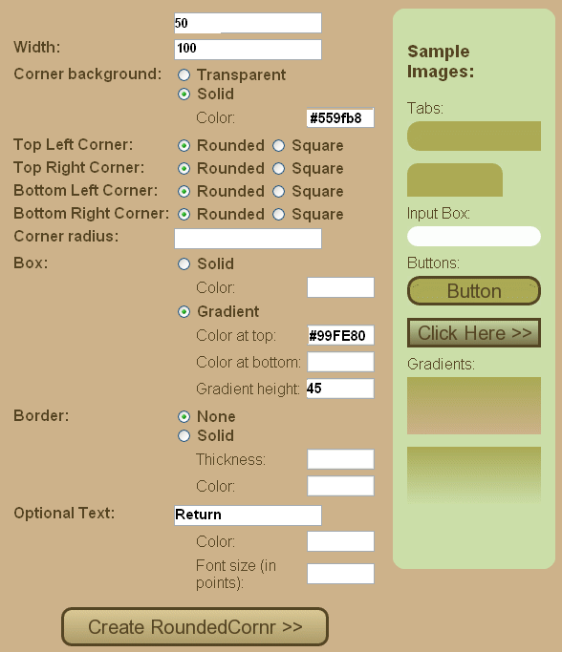
#55fb8

#99FE80

Height es el alto

Para botones de menu ponga #559fb8 en Box Color y Bottom Right Corner y Left Corner de tipo Square

CORNER: lo recommendable es transparente o del color del background en donde estara el buton

GRADIENT:
Escoja un color brilante en la parte de arriba,
El alto del gradient debe ser menor al HEIGHT

OPTIONAL TEXT: El texto del button

Asi se mirara



Luego salve el archivo .GIF a continuacion en una carpeta

Para agregarlo al proyecto, escoja agregar Existing Items….

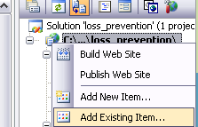

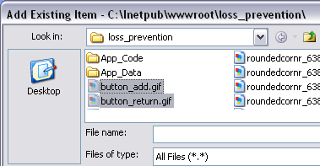

Y luego agrega Image Buttons

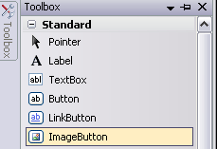

Y asigna las imagenes en el URL

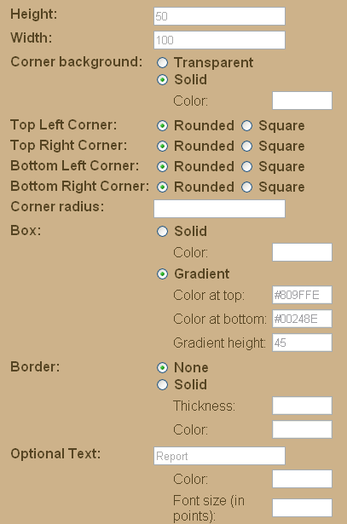
#809FFE
#00248E

AZULES

